Practical Placement Report

Jakob Kümmerle and Antonia Appel

Karlstad Business School / Karlstad University
Information Systems – ISGC99
Date for Submission 2019-03-29
Table of Content
Table of Figures II
Table of Tables III
1. Introduction 1
2. Placement 1
3. Assignments during the practical placement 1
3.1. Ozlab 1
3.2. Testing Process especially for the Eye-Tracker 5
3.3. Mobile Applications 10
3.4. Eye-Tracker 12
3.5. Video Conferencing 16
3.6. Iterative Process 20
3.7. Modelling and Sculpting 22
3.8. Additional Tasks 23
3.9. Weekly Reports 24
3.10. Assessment of IS Theory 24
4. Attended lectures 25
5. Relation to earlier studies 26
5.1 Web Development 26
5.2. Test Management 27
5.3. Testing Process 27
5.4. Intercultural Competence 27
5.5. Work on Scientific Papers 28
6. Final Reflections 28
7. List of Sources 29

Table of Figures
Figure 1 Example of an updated video scene 3
Figure 2 First test design of the consumer agency 8
Figure 3 Set up and initial configuration of the Eye-Tracker 9
Figure 4 Jakob measuring and configuring the Eye-Tracker 10
Figure 5 Maze 12
Figure 6 Analysing our first test by using the Heatmap feature 13
Figure 7 Additional Analysing and interpretation of the test results 13
Figure 8 Gaze Plot data displayed for the consumer agency’s test 14
Figure 9 Jakob working together with Norwegian research student to set up her test 15
Figure 10 Tobii Studio Error Message regarding the Web Add-On 16
Figure 11 Idea of the Navigation App. Antonia is connected to the Test Leader while she receives navigation information on the Ozlab prototype. 17
Figure 12 Updating and preparing the different test devices 19
Figure 13 Scheme of the basic iterative Test Process (by Antonia and Jakob) 20
Figure 14 Two student experimenters analyzing their test data of the second round of testing 21
Figure 15 Example of Areas of Interest shown in the of the questionnaire 21
Figure 16 Statistical Analyses of the Areas of Interest, visualised as a bar chart 22
Figure 17 Designing a simple chair with the tool Blender in the innovation park 23

Table of Tables
Table 1………………………………………………………………………………………………………………………………………………9

Introduction
Antonia Appel and Jakob Kümmerle, we are two students studying “International Management for Business and Information Technology” at the Corporate State University in Stuttgart, Germany. In order to enhance our international experience, we get the opportunity to absolve our fourth semester as part of the ERASMUS program in a foreign country. Therefore the two of us have decided to spend the spring semester 2019 at Karlstad University in Sweden. On the one hand this enables us to experience the differences between the academic system in Germany and Sweden and on the other hand we can sharpen our international conciseness by interacting with as well as adapting to a foreign culture.

Placement
Apart from our regular courses that we are taking at Karlstad University we got to participate in a special course organized by John Sören Pettersson, which is called “Practical Placement”. Over the course of ten weeks we spent our time in the Usability-Laboratory and worked as research assistants.
Purpose of this study-segment is to ameliorate our knowledge of how to conduct scientific research and at the same time get practical experience concerning usability and prototyping.
Our study program in Germany is very praxis oriented. This practical placement was therefore an additional way to prosecute the overall practical emphasis of our studies.

Assignments during the practical placement

Ozlab
Ozlab is a web-based interactive prototyping tool, developed at Karlstad University in order to allow early improvement and testing of prototypes. Since its introduction, it has been becoming an increasingly important method to include user feedback throughout the whole software development cycle. Ozlab provides an easy environment to test new functionalities without actually having to program them. This is extremely helpful - especially in the early stages of development - because even unexperienced developers can use this tool and get the chance to experiment with innovative ideas. Research has shown that fixing mistakes and adjusting prototypes and Websites before the actual programming can save a lot of time and money throughout the following development process.
The first week in the Lab was about getting to know the Ozlab system and collecting additional information about the background and history of Usability Testing.
After we had got an introduction to the general setup of Ozlab, we created our own simple prototype to get familiar with the system and its functionalities.
In general there are three different roles in Ozlab: the Test Leader (TL), the Test Participant (TP) and optionally the Test Viewer (TV). All of the users can access Ozlab from a different device through the web browser. Ozlab works best with Google Chrome.
In total the Web-Application consists of two separate sectors: the Shell-Builder and the Interaction Shell.
Shell-Builder: This is where the creation of the prototype takes place. A simple selection of visual objects can be inserted into a screen, which resembles a certain page of the desired application or Website.
Interaction Shell: Here the TL and TP enter Ozlab with two different devices. While the TP interacts with the Mock-up of the Application or Website, it is the task of the TL - also called Wizard - to manually interfere and change the screens or objects according to the desired functionality. The TP only observes the finished action and therefore experiences the feeling of a real function.
In our self-created prototype, we tried to include all objects and available functions of Ozlab. Afterwards we could test every option in the Ozlab Interaction Shell and experienced the different views of TL, TP and TV. To also be able to evaluate the functions, which are only available on mobile phones, we tested the shell on our own devices. One of the realizations that we found out and documented was that functions differ depending on whether Android or IOS is used.
Task: Improving the Ozlab Guide:
For new users of the Ozlab system, there is a guide available, describing the individual steps to create and test a prototype. We reviewed each step to verify that the guide includes all relevant information. Furthermore we could make some suggestions about rephrasing existing information or adding additional content where we saw it helpful. We also added some additional screenshots of Ozlab where it was necessary.
We cross checked our analyses of the Ozlab manual to make sure all the introduction material corresponds. Even small distinctions could confuse the user who is trying to familiarize himself with Ozlab. During the entire Practical Placement we tried to always update the manual when we learned anything new about Ozlab. Erik Framner, a student at Karlstad University, also reviewed our version of the Ozlab guide and gave additional input. Even though we could often agree about where we would like to change the wording of the guide, it was quite difficult to pick the adequate phrasing.
On the one hand the user is eager to scan through the information as fast as possible to get started. That means that any unnecessary sentence should be avoided. But on the other hand missing information will aggravate the user’s customization with the site.
Task: Update the Ozlab Videos
In addition to the guide, new users have access to Ozlab Introduction Videos.
We analysed the existing Ozlab videos to figure out how we can improve them. We observed that there is an address bar on top of every page in the videos, showing the URL of the Ozlab site. This is not wanted and should be avoided in a new version of the videos. Our task was to fix this problem by editing the videos. We did some online research on video editing in order to get familiar with the video editing tool called Camtasia. This tool is already installed on the computers in the lab and just had to be updated. Then we started to blur the address bar whenever it was visible in the videos. The result can be seen in Figure 1. This turned out to be more difficult than anticipated because the screen size in the videos had been constantly adjusted in order to highlight specific areas of the screen. Therefore the location of the address bar also changed and we had to adjust the blurred areas according to the current window size. Finally, we successfully eliminated all visual traces of the URL and saved the finished videos.
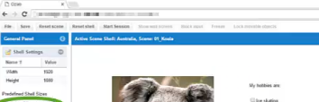
Figure 1 Example of an updated video scene
Task: Introducing Students to Ozlab
Multiple Karlstad University students were looking forward to including Ozlab in their study or research for different reasons. Our job, as research assistants, was to give them an introduction about the background and history of Ozlab and Usability Testing in general. Additionally we assisted them with their projects, helped to set up the tests, and tried to find solutions whenever problems occurred. For all upcoming questions we were the contact point they could turn to.
The first Introduction of Ozlab was on the 4th of February to a Bachelor student who is looking forward to using the Ozlab Technique for his exam work within the CriseIT research project.
We prepared the lab for him and picked him up to guide him the way to the Usability Lab. We showed him the different rooms and facilities and explained the importance of testing Usability and User Experience.
Afterwards we gave him a presentation of the Ozlab Shell-Builder and made some examples on how to carry out the tests in the interaction shell. We also demonstrated how he can use Ozlab on his own phone so he has more possibilities to interact with his upcoming Test Participants.
In week 5 two more students - a master student in Information System and a PhD student at Computer Science - wanted to refresh their knowledge about Ozlab. They have learned about the system before, but had not used it yet. We answered several questions they had, for example how to use the function with the invisible rectangle (Look-Clickable object) and how to add object behaviour to it (by clicking on it Ozlab should automatically switch to a different scene). We showed them how to make objects snap and how to use Check Boxes and Radio Buttons correctly.
On the 8th of March we gave an introduction of Ozlab to two other master students: one form India and one from South Africa. We helped both of them to develop their own projects.
The first of these students wants to present a prototype of a Management and Booking System to a company in South Africa. This website should give the customer an overview over all products the company has to offer. Furthermore it should be possible to select multiple items from a given basket. The price of all selected items should automatically be calculated. This student had already started creating her prototype with a different program but after our explanation of the Ozlab Methodology she decided, the advantages of a faster feedback can help her to improve her design more efficiently.
For example, we showed her, how she could execute her tests with participants in South Africa, using different Video Conferencing Tools (More in 3.5 Video Conferencing). Later that week, we had several other meetings to discuss about her project. We answered all her questions; for example if it is possible to put some objects in front of other objects (Z-index) or if there is a possibility to select all “Checkboxes” with just one click.
She also had problems using Ozlab on her own computer, because the University Wifi (Eduroam) was really slow. It took her more 10 seconds to change anything in Ozlab. We recommended her to use the computers in the library or other computers at the university.
One of her concerns was that she did not know where to proceed with her testing. We helped her to book two computers in a computer room, because our lab was fully booked for this week. (She needed the second computer for the Skype connection, not for the test participants TP view as they were in South Africa.)

Testing Process especially for the Eye-Tracker
One of the most important factors when it comes to Website Design is the Websites Usability.
In software engineering, Usability is the degree to which software can be used by specified consumers to achieve quantified objectives with effectiveness, efficiency, and satisfaction in a quantified context of use.
If the user enters a website and is not satisfied with its specifications, there is a high chance that he will leave the site to find an alternative. Therefore, the main goal when designing a website is to make it as convenient as possible for the user to achieve the task that he was trying to achieve when first entering the website. The Swedish Consumer Agency runs a website where they inform the users about important rights and obligations that they have as a consumer in Sweden. For them it is of the highest importance that their users understand the purpose of their website and to have a self-explanatory design. That was the reason why they chose a test layout were they showed the TP their own website as well as websites of similar structure. The TP was always invited to carry out a small task on each website and then give his or her feedback, answering the same questions for all websites. This setup helped them to compare the different websites and receive more information about what their potential users expect and appreciate on their website.
In order to continue their analysing at their office and prepare the next test we helped them to export all relevant data. Tobii Studio features several distinct exporting tools. The videos can be stored and exported in mp4 to review them later and show them to the designer or developer of the website. Furthermore, the exact data can be displayed in an excel sheet giving precise information about the location of each fixation of the TPs pupil.
The Usability Lab consists of three main rooms: The Welcome Room, the Test Room and the Surveillance Room. The TP will only see the Welcome Room and the Test Room.
Between the second and the third room there is a surveillance glass wall. That means that it is only possible to look through this wall from one side, from the Surveillance Room. The TP will think that he or she looks into a mirror from the Test Room.
In the Welcome Room the TL greets the TP. This room should be comfortable with some seats and a table. At the beginning of the test it is important to introduce yourself, as the TL to TP, offer them a drink and a snack and tell them to wait in the Welcome Room until you are ready for the test. They might have to sign an agreement stating that you as a TL are allowed to use the data after the test. It is also necessary at that point to explain to the TP the characteristics of the test and what exactly will happen with the recorded data. The TP should know why they came here for the test, what will be tested and how it is going to be tested. It is important to let the TP know that you are testing a Website and not the TP.
When everything is ready the TP is allowed to enter the second room, the Test Room. In this room the participant should take a seat in front of the computer with the Eye-Tracker. He or she should find a comfortable position, because they must stay like this for the whole test. Show the TP the Eye-Tracker and the camera and tell them that they will be recorded during the test.
At this point the TL can already start asking general questions that are related to the test and may be interesting for analysing the data afterwards. This could be: “How many hours a day do you spend on your phone/ the internet?”,” What is your favourite website and why?” This is also a good way to get to know the TP better and to make them feel more comfortable with the whole situation.
After this, the calibration of the Eye-Tracker starts. The participant has to look into the Eye-Tracker, until there is a green line on the screen. Then he or she has to follow a red circle with a black dot in it with their eyes, on the screen. The red circle is moving to every corner of the display and at the end to the middle of the display. If necessary a recalibration is possible. After this the participant has to look at the display again until there is a green line on the screen.
If everything fits, the TP can start the test by clicking on “Start Recording”.
Before the test finally starts the TL should tell the TP not to move their position or their head too much during the test and to always keep their eyes on the screen. Otherwise the data is inaccurate. Also the Eye-Tracker cannot record the eye-movement if the TP is not looking at the screen. In addition, the TP should know how long the test will take, what to do if they have questions during the test and how to end the test, if they are done. This could be for example by clicking something on the screen or by pressing any key. The TL should ask if the TP has any more questions before the test starts.
During the test the TL can decide whether he or she wants to stay in the Test Room or go to the Surveillance Room. It is always better not to interrupt the TP during the test and therefore it is recommended to leave the TP alone in the Test Room. However in some tests it can be good to stay with the TP, for example if the TL wants to ask questions throughout the test or if the test is so complicated and long, that the TP might have questions during the test.
If there are two test leaders, one can stay in the Surveillance Room to monitor the test and the other one can stay in the test room, behind the TP, just in case the TP has questions.
After the TP finished the test the TL should tell the TP that they did a great job. At this time the TL can ask more questions about the test itself, the tested website or about the testing process.
Some example questions:
Questions about the test itself: “How did you feel during the test? Do you have any questions, which were not answered during the test?”
Questions about the website: “Would you use this website? Would you recommend that website to a friend? Was it clear what the Website is about?”
Questions about the testing process: “Was it clear throughout the test what you had to do? Did you have too much or too little instructions?”
Before the TP leaves, the TL should thank the TP and offer them another snack. After this it is time for the next TP.
Throughout the whole process it is really important that the TL always tells the TP what is happening right now. Tell them about every step of the testing process and try also to explain the obvious things. If it is the first time for the participant to be part of such a test, it can be scary and exciting for them. In the best case the test is self-explanatory and all information that the TP needs is included. That means that the TP can do the test alone and the TL can watch the test. That is how you get the best data. After all the tests are done, it is time to analyse the data.
Our experience with the Testing Process:
Already in our first week we got the chance to experience how the testing process works. On the 25th of January we started the day by preparing the lab for our guests from the consumer agency. The three women - Marie, Natalie and Malin – from the Swedish Consumer’ Agency visited the lab with the intention of exploring the options of using Eye-Tracker software to optimize the Usability of their websites (Figure 2). The real test should take place a few weeks later.
At the beginning Henrik Andersson gave them the introduction to the facilities and systems and we served as assistants. After that, Henrik Andersson left and the two of us were able to guide them through the testing process. We showed them how to use the Tobii Studio Software and the Eye-Tracker and explained what options they have to test their website. Furthermore, we helped them to create their own little project to get to know the program. In the end we functioned as test-participants ourselves. In addition we could also assist them by analysing the data afterwards and showing them possibilities of visualizing and exporting the data.

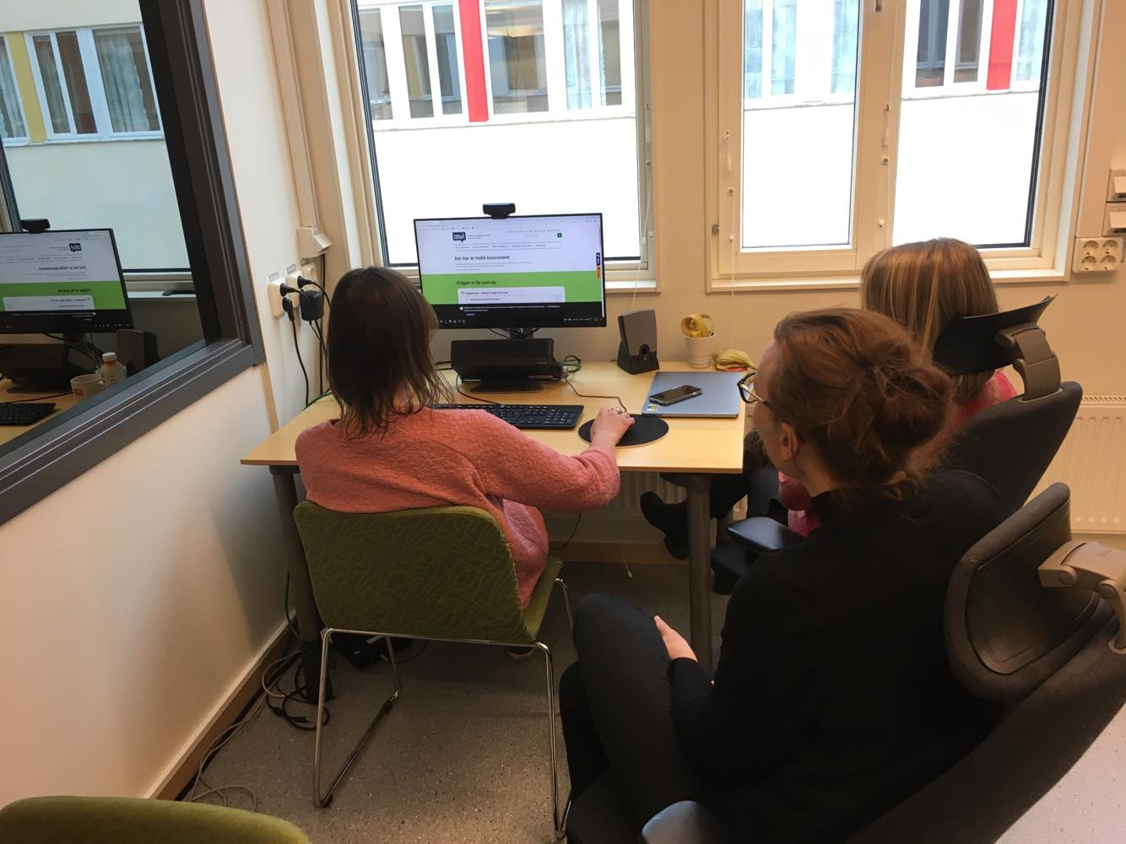
Figure 2 First test design of the consumer agency

On the 12th of March the three women from the consumer agency came again to set up their tests with the Eye-Tracker for Friday the same week. We gave them another introduction to the most important features of the Eye-Tracker. One week earlier a problem with the Eye-Tracker software occurred, due to a software update. We explained the problem to them. The solution for that day was to just use screen recordings instead of the Web Browser function. We both played TP for the test of the consumer agency. They tested 5 different websites and asked a few questions afterwards. We also showed them how to save and analyse the data.
In addition, we set up a Test Participant list for this Friday for the real tests of the consumer agency which you can see in Table 1.
The only requirement for the TPs is that they are able to speak Swedish. We arranged to have a mix of TP, including one teacher, Bachelor and Master Students and people with and without IT experience.
Table 1 List of participants for Friday 15.03.2019--Consumer Agency testing
9am – 10am | Third year bachelor student
10am – 11am | Third year bechelor student
11am – 12am | Master student
1pm – 2pm | Teacher
2pm – 3pm | Master student

For Friday the 15th of March we had to prepare the Usability Lab and the Eye-Tracker for the upcoming tests. Therefore, we had to recalibrate the Eye-Tracker as well as measure and scale it (displayed in Figure 3 and 4). This took us longer time than we expected, because we first had to look online how to do it and we had to find the program for the setup on the computer.
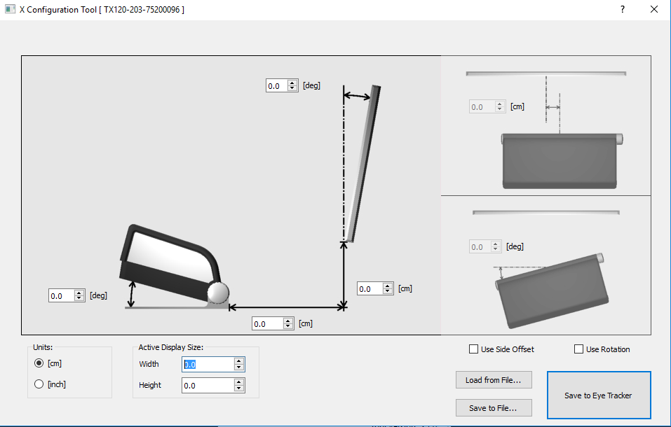
Figure 3 Set up and initial configuration of the Eye-Tracker
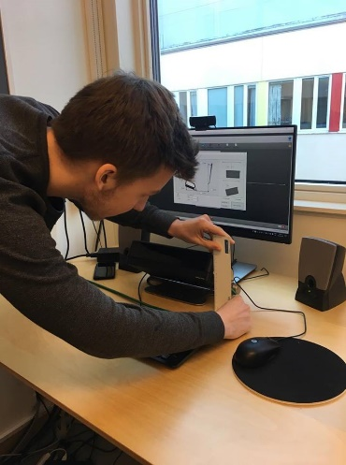
Figure 4 Jakob measuring and configuring the Eye-Tracker
We got the two computers, the Eye-Tracker and the speaker ready. After that we helped Marie Myhr to set up the test environment. During the tests we helped as assistants and answered questions whenever it was necessary. In between the tests we helped analysing the data. After the last TP left we exported the data for the consumer agency and showed them again how to analyse it.

Mobile Applications
One of the graduated students in the Karlstad Master’s Programme in Information Systems, Tobias Bernström, has designed a concept for a mobile phone application of Ozlab to deal with some of the disadvantages of using a web-based tool. This app is called the Ozapp. He wrote a research paper about his work for a master course.
In week 6 we examined this paper, which he had commented and summarized the most important information for John Sören Pettersson.
In the research paper he first gives an Overview of different types of prototyping (Low-fi and hi-fi prototypes) in a mobile context. After that he explains the concept of Ozlab and why it is useful to have an Ozapp while using a phone and testing a website. He states the problem with the web-based Ozlab and the requirements for the Ozapp.
In the end of his paper he explains how the Ozapp works and how the flow of Ozlab and the Ozapp implementation works through a diagram. He also refers to the Ozapp backend and the future work that needs to be done.
In addition to the examination of the research paper we should download the Ozapp on different devices to try it out and share our experience with Tobias Bernström, John Sören Pettersson and Malin Wik.
We received an email letter from Tobias Bernström with the instructions on how to install the Ozapp on our mobile devices. He sent us a link to a google drive folder and we tried to download the app. It worked quite well with Jakob’s phone (Android, Galaxy S8, Model Number: SM-G950F), but we had trouble with Antonia’s phone (IOS, Iphone 6S, Model Number: MKQP2ZD/A).
Jakob downloaded the file on the computer and then saved it as a zip file. After that he sent the zip file to his phone. By doing so he was able to install the app on his device. Antonia downloaded the app from google drive and tried to execute the installation process. She also intended to install it using the “Expo Client” as this was suggested by Tobias Bernström. Unfortunately this did not work either. She just got several error messages.
The two of us spent the rest of the day testing the Ozapp on Jakob´s Android device. We tested all available options in the app, for example swiping, different links and snapping objects. Unfortunately, we were not able to test the vibration function.
We came up with several suggestions and questions concerning the app:
- After downloading the app a lot of different, unnecessary folders were created on the phone with only one or two documents in it. We had to delete them all separately, which took a lot of time.
- There is no “Back” button available while using the app in active mode, making it difficult for the developer/tester to make changes. This is positive as the TL may not want the TP to go back in the app, but it can also be negative, as it confuses the TP.
- It is possible to interrupt the test for the TP, when he or she receives for example a push-up message during the test or some other push notification. If this happens the TL loses control over the test. Therefore push notifications should be turned off during the testing.
- Sometimes the connection between the phone and the computer stopped working during the test. The only thing that we could do to reconnect was to close the app and restart the test.
- We also sometimes had problems with opening a new shell: the new shell was displayed on the TL device but not on the TP phone.
- We did not manage to use different sensors, for example the vibration.
On the 4th of March we listened to the presentation of Tobias Bernström about his research on the Ozapp. Afterwards we gave him feedback on the app and shared our experience of testing the app in the previous week.
In addition, we also collected our findings about the Ozapp and send them to Tobias Bernström. This was necessary, so he could add them to his report which he needed to complete in order to get a grade for his course.

Eye-Tracker
Already in our first week in the Usability Lab, we started working with the Eye-Tracker. Henrik Andersson showed us what an Eye-Tracker is and how to distinguish between different types of Eye-Trackers. We experimented with the Eye-Tracker by playing different games so we could get a feeling how the technology works. One game, where we had to target different objects on the screen just by looking at them, was very challenging for us. We had to change the calibration several times to finally achieve the desired effects and continue with the game.
In addition to that Henrik Andersson gave us a short introduction to the Tobii Studio program. Tobii Studio is the Eye-Tracker software used at Karlstad University and as such has some specifications that need to be learned before creating or analysing a test. Again, the best way for us to familiarize ourselves with all the different functions was to simply try it out ourselves. We did so by developing a simple test with Tobii Studio. We set up a game, where the TP has to find the right way from one end of the picture to the other end (Figure 5). We wanted to know how TPs would solve that game.
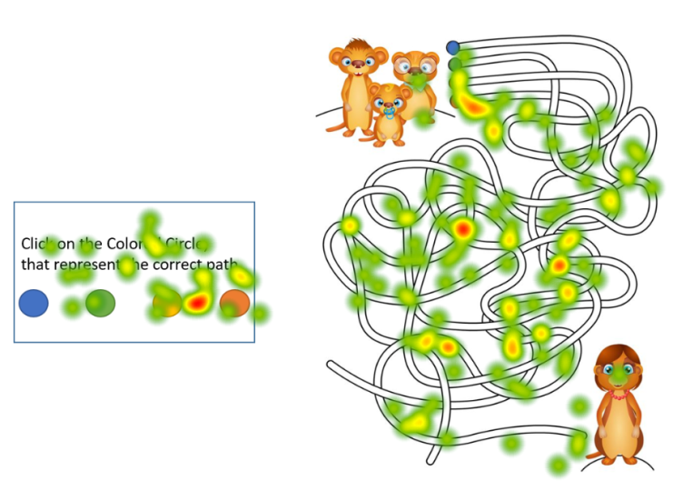
Figure 5 Maze
After that we created a test with three different pictures, where the TP had to look for the hidden animal (Figure 6). After setting up the calibration we asked students of the departments close by to participate in the experiment and followed them through the test. While the TP performs the task on the screen the Eye-Tracker follows his eye movement and collects the data.
Analysing this data let us draw conclusions while at the same time getting to know the functionality of the system. It was very interesting and surprising to see, how different people acted differently in our small test.
Some of them found the animals really fast, scanning the page from left to right, others needed a lot of time and used the strategy to alternate their view between the pictures.
Most of the students were really confident while doing the test, others were insecure and asked a lot of questions before, during and after the test.

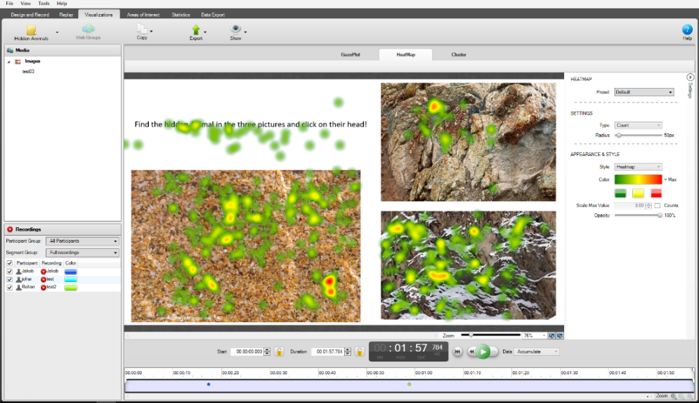
Figure 6 Analysing our first test by using the Heatmap feature

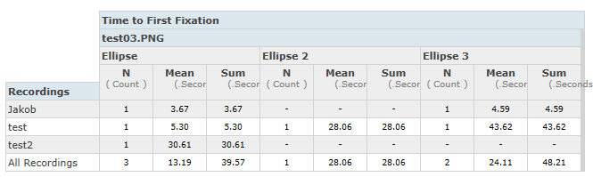
Figure 7 Additional Analysing and interpretation of the test results

How does the Eye-Tracker work?
Infrared or near-infrared non collimated light is used on the center of the pupil to create corneal reflexions. The collected data can then be displayed in the form of Heat Maps and Gaze Plots. Heat Maps are most commonly used to determine the time of fixation on a certain area of the screen. Gaze Plots display the sequence in which the TP scans the page with his or her eyes. Figure 8 shows an example of the result.
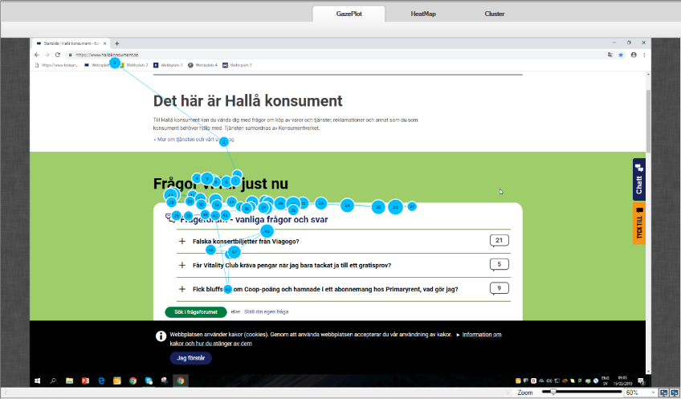
Figure 8 Gaze Plot data displayed for the consumer agency’s test

Task: Introduction of the Eye-Tracker to students
Two students from the Business School, wanted to learn more about how to use the Eye-Tracker for research studies in the second week. On the 21st of February we explained them the usage of Tobii Studio and gave them tips on how to improve their research results by optimizing the test setup. Afterwards we made plans to arrange upcoming meetings for their project. We also readjusted the calibration settings so they are more suitable for their test.
In addition, the IS master and the CS PhD student whom we had helped with Ozlab prototyping now wanted to reap the benefits of Eye-Tracking for their studies. We showed them how to create and execute tests with the Eye-Tracker and what considerations must be taken into account when interacting with test persons during the test. Throughout the whole testing process we were able to answer their questions and help them whenever problems occurred.
On the 27th of February we gave two PhD students in Computer Science an introduction to the Eye-Tracker software.
On the 13th of March we gave one of them, who is a visiting research student, another instruction to the Eye-Tracker and went through her test with her. We played TP for her to make her more comfortable for the upcoming tests (Figure 9).
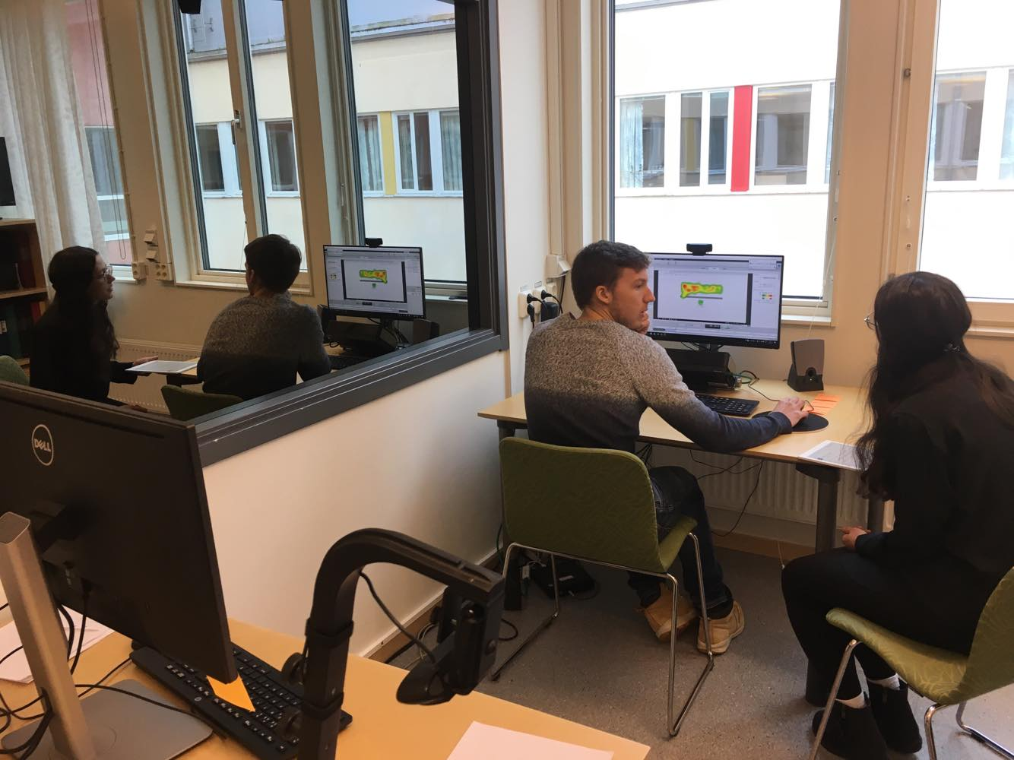
Figure 9 Jakob working together with Norwegian research student to set up her test

Problems with Tobii Studio
Even though most of the tests ran smoothly, some problem occurred before our big week of testing. In the previous weeks it had been possible to use a Web-Shortcut when doing tests with the Eye-Tracker. However, from one day to another this convenient feature was not available anymore (Figure 10). We tried to fix the problem by using different Web Browsers. When this didn’t work we got in contact with the IT support as well as Henrik Andersson. There we found out that the Version of Tobii Studio used in the Lab is not the newest Version and does not get frequently updated. The correct guide book showed us, that Windows 10 is not supported by this Version anymore and only Internet Explorer can be set as the default Web-Browser for the Add-On. Later we had a meeting with a staff from the IT support who tried to help us fix the problem with the Eye-Tracker. The only solution we came up with would be to reinstall the whole Tobii Studio. In addition to that we would also need to do a reset of the computer. Due to all the test data being stored on the computer, it is necessary to save all the relevant data first and do a Back-up. We decided to not do this during our time in the Lab, since so many groups were planning to use the Eye-Tracker in the last weeks of our stay. In addition, the whole process of recovering the Web Add-On would take a long time and prevent us, the other students and the consumer agency from continuing the tests.
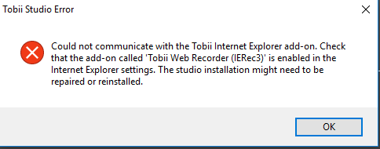
Figure 10 Tobii Studio Error Message regarding the Web Add-On
To still be able to conduct Website-Analysing tests we found a workaround. Instead of using the Web Add-On we used the Screen Recording feature of Tobii Studio and opened the Web Browser manually in a new tab. The advantage of this strategy was also, that now - instead of just Internet Explorer - all Browsers could be used. The only disadvantage was that a few functions in the analysing view, like for example comparing different Gaze Plots side to side, where no longer available.

Video Conferencing
Sometimes the TL wants to do a test with a TP that is not physically in the Usability Lab. Then the TL needs to know where the TP is and what the TP sees. That is possible for example with different Video Conferencing Tools or Photo Sending Tools.
At the beginning we had a meeting with Malin Wik and she explained us what the task is about. She already worked on this topic, so she showed us what she already did and what she wanted from us. We first looked through the information that Malin Wik gave us to evaluate how much research has been done already to build up on that.
In general, the intention of using Background-FaceTime applications is to allow the wizard to interact with a TP who is not physically present in the Usability Lab. That means, that the TL is for example sitting in the Usability Lab and the TP is walking around the university with his or her phone.
We created a special Use Case to make this task more tangible. The Use Case is that a Navigation App should be designed. The app should help students find their way through Karlstad University.
For doing tests with a prototype of such an app, the TL needs to be able to follow where the participant is located in the university via video or photographs (send to the wizard). That means that the app should be able to know where the TP is located, through their camera. Then the app or the wizard behind the app can tell the TP whether to turn left or right, as Figure 11 tries to illustrate.
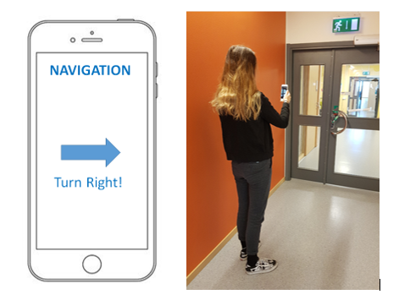
Figure 11 Idea of the Navigation App. Antonia is connected to the Test Leader while she receives navigation information on the Ozlab prototype.
We started the task by doing online research on general online conferencing software to get familiar with the different options of online surveillance tools. We categorized them according to their specifications. We talked about how different web-based video conferencing systems could be directly embedded in the Ozlab prototype and which video conferencing systems ought to be tested.
We agreed on a limited number of conferencing tools to lay our focus on them. We tested Video Solutions and Photo Solutions.
As for the video conferencing tools we differed between embedded tools (Appear.In, Embedding Web RTC Video Chat and TokBox) and non-embedded tools (Skype, Zoom, Blizz, Google Hangouts, Google Duo, Facebook Messenger and Whatsapp messenger).
Therefore it was necessary to first look into the definition of embedded tools and the reasons why you should or should not use them, because we were not so familiar with that topic.
Ozlab provides a function where it is possible to embed code in the property section of one of the objects: the label object. This is often used to embed iframes for example for YouTube videos or simple HTML code. In our case we wanted to try embedding a video conferencing tool so the connection can automatically be started and controlled by the TL when he opens a certain screen in Ozlab.
After testing different tools and researching their advantages we came to the conclusion, that embedding them is an in-efficient solution because it takes a long time to set it up and the connection has to be restarted with every new page the TL opens.
Another, even more severe, disadvantage is the fact that most browsers block the content displayed in the embedded frame due to security setups. To deactivate these security installations would make the computer itself vulnerable towards cyber-attacks and is not recommended. Since Ozlab is running on a http setup and not a https setup even a workaround with less acquainted browsers is not possible. That is why we decided to concentrate our research on non-embedded software.
In general we looked for different apps, that we can use while also using Ozlab. That means that they should either work in the background or the screen should be shared (Ozlab and the Tool). We used Ozlab and one social media at the same time.
At first we worked with two different devices:
- Jakob’s Phone (Android, Galaxy S8, Model Number: SM-G950F)
- Antonia’s phone (IOS, Iphone 6S, Model Number: MKQP2ZD/A)
Some of the applications and tools do not work in the background. For example Skype just stops the video when the TP leaves the Skype App to use Ozlab. That is why we had to use multi-screen.
That means splitting the screen of the phone in two parts. This is only possible with Android devices, as they have the multi view function. Every 10 seconds the TP sends a picture manual via social media, to show the TL his or her position.
We continued testing Ozlab and social media at the same time. This time we did this while walking through the university. The TP tells the TL where he or she wants to go and sends pictures of his or her position. Responding to that the TL navigates the TP through the university. We experimented using this while walking through different corridors at university. One of us acted as the TL, staying in the Lab, the other one acted as the TP, walking through the university.
To test all the different tools we needed to create several accounts. We created a separate email address, which we planned on using during our tests.
We started to test the embedded tools. This was harder than expected, because we first had to find the source code for that online. We tested the tools in different browsers and therefore first had to download Opera. We got different error messages depending on the browser. Afterwards we took several screenshots of different error messages to make our report more concrete and clear. We wrote all information down and organized the notes.
After we tested all the tools on Jakob’s phone, we started preparing the different devices Malin Wik gave us: an Apple ipad, a Samsung tablet, a Samsung phone and a Sony phone. (Figure 12)
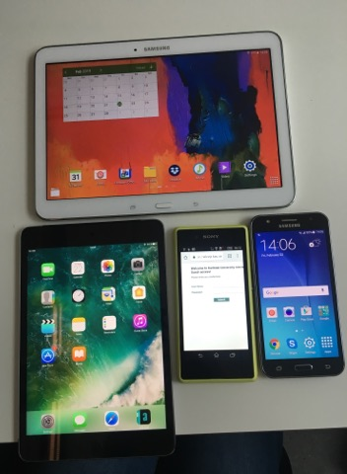
Figure 12 Updating and preparing the different test devices

We connected the devices Malin Wik gave us to the internet via guest- access and started to download several applications to test the different video solution tools. Before we could do the tests on the Ipad we needed to set up a new apple ID.
After we tested several tools on several devices, we spend the time designing an excel table with all the information about the video conferencing tools.
In the end we reread the whole report and corrected spelling mistakes and logical mistakes. We tried to rewrite several sentences to make it understandable for everyone.
On the 8th of March we gave bachelor thesis student an introduction to our work of the Video Conferencing Tools. We showed him what we did so far. He will write his bachelor thesis during the spring and wants to use some of the video conferencing tools that we have tried. We talked with him about the different tools and their advantages and disadvantages. He also told us about his thesis and his project. After our meeting with him he revised our paper about the tools and gave us some suggestions on how to improve it. He mailed it back to John Sören Pettersson, Malin Wik and us, so we could have another look at it.

Iterative Process
During our time in the Lab we got in contact with different master and PhD students. Most of them wanted to book the Lab to use the Eye-Tracker and some of them tested their Ozlab-Prototype but used the Eye-Tracker for additional analysis. We organized ourselves and set up a testing-timetable for each week to make sure everybody got a chance to carry out their tests. To further improve our overview over the different projects we created a list where we could see, which student is currently using which URL to access Ozlab. By doing this we can assure, that nobody accidentally interferes with another test because they use the same web-address.
Testing can be seen as an iterative process, learnings from the first test should be considered when creating the second test to further improve the results. Especially for the students who had their first testing experience this semester the first test-results gave them the impulse to change the setup of their test or even modify the testing strategy.
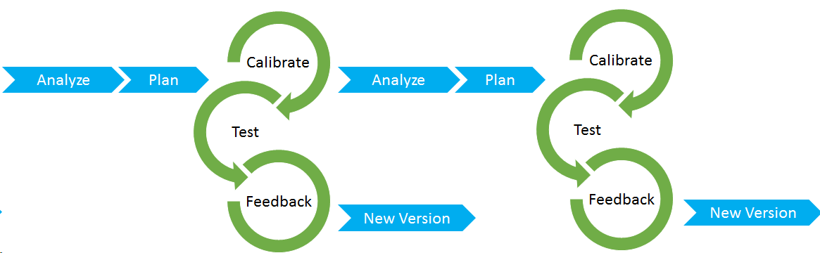
Figure 13 Scheme of the basic iterative Test Process (by Antonia and Jakob)
For example, a couple of experimenters had the problem in their first round of testing that the accuracy of the Eye-Tracker was not satisfying. In order to improve this in the following test round they made sure to explain to all their participants the importance of keeping a constant gaze at the screen and not shifting the head too much. A similar problem occurred during the first test of the consumer agency: They realized that asking questions during the test often results in the test participants turning their head towards the speaker to answer the question. In this particular moment the Eye-Tracker cannot detect any eye-movement so the analysation after the test is not as easy. They changed their strategy in the following tests and displayed the questions on screen. This improved the results a lot and made it possible to have a quicker and more convenient way of analysing.
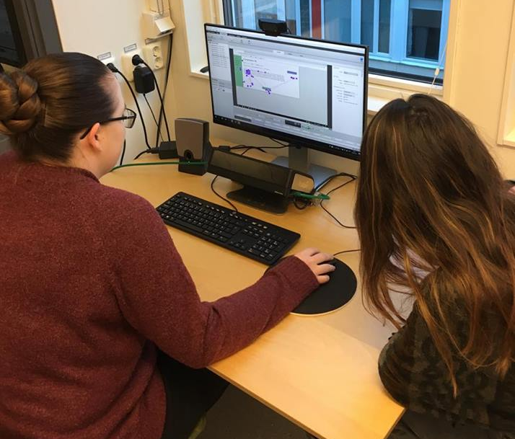
Figure 14 Two student experimenters analyzing their test data of the second round of testing
We spend a lot of time together with the guest Phd student analysing the data of her research project. She prepared an interactive questionnaire with multiple small tasks for her Test Participants and wanted to find out how much attention they were paying to certain keywords in the task description. Tobii Studio offers an additional analysing method called Areas of Interest. There, a specific area of the screen can be selected and then analysed with a set of tools related to descriptive statistics. We showed her how she can find out how long individual Participants took to look at the areas of interest and how long their eyes’ fixation lasted. When she compared the results of all her Test Participants this data provided her the impulse for new interpretations and assumptions.
Figure 15 shows the creation of these Areas of Interest and Figure 16 gives an example of how to visualize the collected data.
Figure 15 Example of Areas of Interest shown in the of the questionnaire
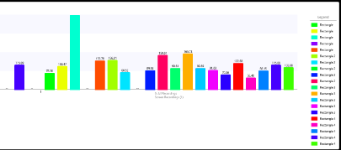
Figure 16 Statistical Analyses of the Areas of Interest, visualised as a bar chart

Modelling and Sculpting
We visited a game development club called “The Great Journey” that had been setting up a new organization in the innovation park at Karlstad University. Purpose of The Great Journey is to provide a platform of shared knowledge and expertise to all students who are interested in game-engineering. There is currently no course available at Karlstad University that would teach this topic so The Great Journey helps interested students to come together and share their experience and ideas to learn more about game development and the skills needed to create their own video game. They gave us an introduction and overview of their work. Afterwards we talked to different people in the innovation park who already have experience in modelling and sculpting tools.
On the next meeting date we started our own little project, working with the tool “blender” to learn how to model real life objects with a visual program (Figure 17). Another student gave us a quick introduction and showed us what steps need to be taken to develop our own video game.
We did additional research about how to use the tool “blender” in order to be prepared for our next game development meeting on the following Thursday. Throughout the semester we attended several of the Thursday evening meetings in the innovation park and continued to build our own expertise in terms of modelling and sculpting.

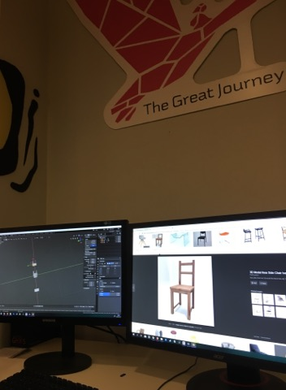
Figure 17 Designing a simple chair with the tool Blender in the innovation park

Additional Tasks
In addition to our main tasks we always helped John Sören Pettersson and the other professors, whenever they needed help. We also tried to get to know as much as possible of the Karlstad University and the work of the professors there.
On the 29th of January a master student who were temporarily employed part-time to evaluate the university’s learning platform, offered us to show us her current work. In order to understand it better she gave us an introduction to the Canvas tool. This is a system used by all professors and lecturers at Karlstad University to organize their courses and distribute information and tasks among the students. However, sometimes unwanted errors disarrange the data leaving it unrecognizable.
In these cases, she can analyse the entered data and manually extract the right information so the professors can organize the course.
On the 13th of February we helped John Sören Pettersson, by supervising three students, who had to write an exam about Usability. John Sören Pettersson had to attend a lecture, so we stayed with the undergraduate students in one room. After they finished the exam we collected their papers and handed them to John Sören Pettersson and Malin Wik.
On the 19th of February we attended the “International Exchange Day” at the Karlstad University. This is an event with the intention to increase internationalization and to inspire students from Karlstad University to go on an exchange. We represented our home university and gave insights about the study opportunities in Germany. We spoke to many other students and answered their questions. In addition we informed ourselves about studying in other countries, for example Thailand and France.

Weekly Reports
Every week we had to write a report about our current work. During the 10 weeks we improved our writing style and also the structure of the reports. Every Friday we sent the report about the last week to John Sören Pettersson and Malin Wik. They often gave us a quick feedback and some tips how we could improve our writing style.
We also had a meeting with John Sören Pettersson and Malin Wik, where we reviewed our reports. We updated the report by adding specific timeslots and dates. Malin Wik gave us a quick introduction on how to write our reports correctly and John Sören Pettersson gave us a few suggestions on how to refine the report. He gave us the tip to always add screenshots and pictures to the reports to make them more realistic.

Assessment of IS Theory
Another task that we pursued throughout our practical placement was the analysis whether or not the Theory of Information Technology could be applied in the practical work. To achieve a better assessment of this question we decided to split our theoretical learnings of this semester in its main components - Usability Theory, Prototyping Theory and Eye-Tracking Theory. The traditional theory regarding Usability is often a composition of different abstract principles. P. Jordan for example proposes a concept that includes five references: guessability, learnability, experienced users performances, system potential and re-usability to evaluate whether the website is ergonomical and therefore user friendly or not. As mentioned in the section about Usability the improvement of Usability on a website can have a huge impact on how the site is perceived by the user. But can a concept like the one described by Jordan help the designer of the Website to improve its Usability or is it too abstract? From our experience in the Usability Lab we can state, that most of the time when establishing new tests, the students or employees of the Consumer Agency preferred to use common sense over theoretical knowledge. Instead of having a detailed plan on how to address different compartments of Usability they chose to use logical thinking in combination to simply experimenting different ideas - and surprisingly, it worked in most cases. The results seemed to be satisfying. The more time they spend creating the tests or analysing their website the better they were able to develop a sensitiveness towards dos and don’ts of website design.
On the other hand, a more practical approach to explain theoretical IS theory like the book “Don’t make me think” by Steve Krug can help inexperienced testers to understand the basics of Usability testing. Krug focusses on real life situations and after reading the book we had the feeling to be better prepared for our previous test rounds.
Our assessment of the Prototyping Theory led to a similar conclusion: While it is definitely interesting to learn more about the history and evolvement of Prototyping and the individual concepts, the method helping us the most was simply creating our own prototype and trying it out on some test participants. Most of the students that needed an introduction to Ozlab were not really interested in the functionality or structure of Ozlab, it was enough for them to know how to use it to keep on working. Nevertheless we think that many questions or problems could have been avoided if they had had more knowledge about the methodology and deeper laying concept of Prototyping tools. Thus we would advise everybody who is new to prototyping to at least understand the idea behind high-fidelity and low-fidelity prototypes before starting to design.
A completely different outcome came through the evaluation of our Eye-Tracking Theory. In this case reading the book “Eye-Tracker -Theory“ and researching additional information on the internet really helped us to analyse and interpret the test results. It would have been extremely difficult to distinguish differences between Gaze-plot and Heat-map data without understanding how they are created. Also it can be said, that the women from the consumer agency had a very mixed level of expertise and the ones that have done some research on Eye-Tracker Theory before doing the test were also the ones figuring out Tobii Studio way faster.
All in all, we can say, that during our time in the Lab, but also when we look back at previous experience with theoretical learning of Information Technology there is a certain basic knowledge that has been proven very helpful in the practical work. However, the effect should not be overestimated. Practical experience through constant confrontation with the IT system often leads to a better understanding and similar results can be achieved even without the previous studies. For the two of us, this has been the reason why we chose to study a praxis-oriented study programme at our University in Germany and it has also proven correct during our time here in the Usability Lab.

Attended lectures
During our time in the lab we attended several lectures.
Already on our first day, the 21st of January we got the chance to attend our first lecture, held by a researcher from another Swedish university about Big Data Analytics. Due to the fact that it was her trial lecture to show her teaching ability and concept, it was helpful to have us – as undergraduate students – following the class to make the environment appear realistic.
On the 7th of February we listened to a lecture, held by a business representative addressing the advantages of using “SAP Business Insight” to facilitate the digitization process in companies.
Since the lecture was held in Swedish we could not understand all the nuances. Nevertheless, we were able to learn more about the different approaches SAP is taking in regard to Big Data, AI, Block chain and Smart Cloud Solutions.
On the 19th of February we attended a presentation about a master thesis: “A Configuration User Interface for Multi Cloud Storage based on secret Sharing”. The master student had to defend his thesis and had to answer questions by Henrik Svensson, a professor from the Skövde University. As the presentation and the questions were in English we could follow the whole lecture. It was very interesting for us to see how such a defending will take place, as we also have to do it at the end of our studies.
Whenever we had the time we attended Swedish lectures, held every Tuesday and Thursday. As we are staying almost half a year in Sweden we want to get to know the culture and the language. We practiced our Swedish during lunch time with the professors or during our free time with other Swedish students. As Swedish is so similar to German it was easy for us to learn the language and to have easy conversations. We will definitely continue learning Swedish in the second half of the semester.

5. Relation to earlier studies

5.1 Web Development
In the third semester, previous to our studies in Karlstad, we have had a series of lectures about web development and Usability improvements. Due to the emphasis on conveying practical knowledge we carried out a project in which we created our own Website - totally from scratch.
During our time at the Usability Lab we came across many similarities between our project and the projects students at Karlstad are conducting. Also in our case we had to make sure to include the feedback of our potential customers to improve our website. Unfortunately, we did not have access to a real testing-facility let alone equipment like an Eye-Tracker.
Dealing with prototyping and testing on a daily basis really helped us to understand the importance of including all those extra elements in the development process. We wasted so much time and energy during our previous project because we programmed first and then asked for feedback. In future studies we will definitely try to avoid these kind of mistakes.

5.2. Test Management
It had never crossed our mind how important it is to use the appropriate words when conducting a test with test participants who have never done a test before. Our experience in the lab showed us that the way to brief the test person can indeed have a great impact on the test results. If the instructions are formulated in an easy-to-understand way and the atmosphere has been relaxed due to small talk beforehand, the Test Participants tend to also approach their task in a relaxed way and act more natural.

5.3. Testing Process
In our practical internships at our company we often come in touch with different forms of testing and different test processes. Before every Software-Update the internal system has to go through a Smoke Test and Jakob has been working in a Department before that has been implementing a Test-Automatisation. But why is Usability testing in particular so important? The answer is rather simple: I, as an user of an Application or Customer on a website, have a certain objective when using the system, I want to achieve something. If I feel like the site is difficult to understand or I simply do not like the design this can prevent me from coming on the site again. The most effective way to ensure that the user has a good experience on a site is to test it.
The more I test and the more often I test the more I learn about which of my ideas work well and which ones do not.

5.4. Intercultural Competence
Since our study is international we had multiple lectures about intercultural management and intercultural communication. In these courses we were applying models and theory about the underlying patterns which distinguish cultures from one another and determines the way people act, think and deal with upcoming problems. Even though Swedish and German culture is not too distinct we noticed certain differences. Being confronted by a foreign language, foreign customs and manners helped to sharpen our cross cultural competence.
We learned how to adapt to new and unfamiliar practices and every encounter with the Swedish culture helped us to be even more open-minded and sensitive toward other people’s behaviour and believes. We also try to learn the basics of the Swedish language and will continue to do so in the second half of the semester.

5.5. Work on Scientific Papers
At our University in Germany we have to hand in at least one scientific paper every year. Writing this final report here at the Usability Lab helped us to find and improve our own concept and methodology to write the upcoming papers next year, which are very important for us.
It helped a lot for example to painstakingly note down the most important takeaways from every day so we could remember all the different tasks and tests throughout the weeks. Of course, we also had less work to do with our final report, since we had already finished parts during the course.

6. Final Reflections
All in all, the experience in the Usability Lab has broadened our perspective on testing and researching and has increased our awareness of Usability flaws in Websites and Applications which could have easily been avoided if an adequate testing process had been established before releasing it. It was also very interesting to work together with the professors and staff and so get an impression of the teaching side in university.
We have both realized that there is more to consider when building a website or application than just a “nice design”. It has been our first time being confronted with real research methodology and testing without the corporate environment that we would have while working at Daimler. The way of teaching and learning is quite different from what we are used to in our home university. There, most of our lecturers are people that come from the same industries that we desire to work in and often they all share similar conceptual approaches to solving problems. The students we have worked with in Karlstad have a more diverse background and don not necessarily have the intention to conduct the most profitable research but rather the solution that simply satisfies them the most.
We think in our upcoming semesters we can take some of the ideas and methods which we found most appealing and use them for our own research. We also plan to refine our web-programming skills so we can combine the two areas Web development and Usability to realise our own ideas and create meaningful web content.
We would like to thank everybody who has helped us to carry out our tasks and gave us a warm welcome to Karlstad University!

7. List of Sources
1. Bergstrom J. R./ Schall A. (2014): Eye Tracking, in User Experience Design, first edition, Morgan Kaufmann
2. Bernström, T. (2019): Ozapp
3. Pettersson J. / Molin L. (2003): How Should Interactive Media Be Discussed For Successful Requirements Engineering?, Chapter 5 in: Burnett R./ Brunstrom A./ Nilsson A. G.: Perspectives on Multimedia, Communication, Media and Information Technology, John Wiley & Sons, Ltd
4. Jordan P.W./ Draper, S. W./ MacFarlane K. K./ McNulty S. A. (1991), Guessability, learnability and experienced user’s performances, in: Diaper D./Hammond N. (eds.) People and Computers VI. Cambridge University Press:
5. ISO 9241-211: Definition of Usability {International Organization for Standardization}
6. Krug, S. (2014): Don’t make me think, A Common Sense Approach to Web and Mobile Usability, third edition, United States of America: New Riders
7. No Author (2016): Tobii Studio, User’s Manual, Version 3.4.5.
8. Wik M. (2018): Ozlab Guide, Karlstad University Sweden

Bergstrom J. R./ Schall A. 2014
Wik 2018
Wik 2018
ISO 9241-211
Krug 2014
Krug 2014
Bernström 2019

